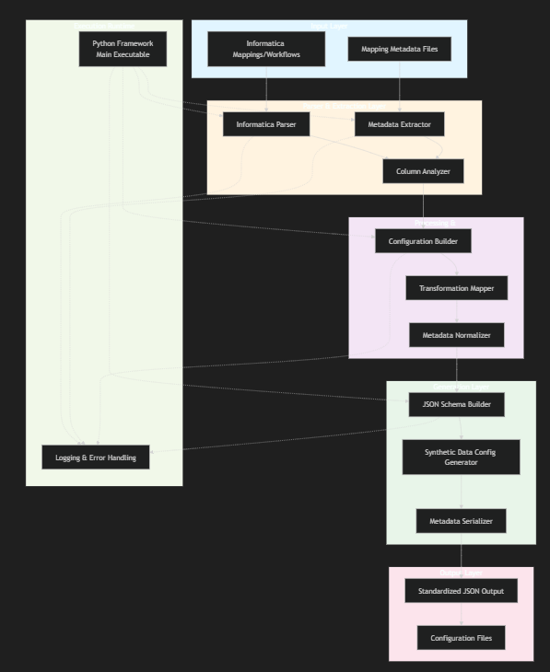

Architecture Overview
The diagram illustrates a 6-layer architecture for your Informatica metadata handling framework:
Input Layer - Receives Informatica mappings and workflow metadata files
Parser & Extraction Layer - Parses Informatica formats and extracts metadata, with column analysis for synthetic data requirements
Processing & Transformation Layer - Normalizes metadata and maps transformations to standardized formats
Generation Layer - Builds JSON schemas and generates synthetic data configurations with all needed metadata
Output Layer - Produces standardized JSON configuration files ready for synthetic data generation
Execution Runtime - Python framework manages the entire pipeline with centralized logging and error handling
This modular design ensures the framework is executable, maintainable, and can process any Informatica workflow into standardized JSON configurations containing column details and transformation information.
s

Python_projects/
├── informatica_framework.py # Main framework module
├── utils.py # Utility functions and helpers
├── example_usage.py # Usage examples and demonstrations
├── requirements.txt # Python dependencies
├── README.md # This file
├── logs/ # Log files directory
│ └── informatica_framework.log # Application logs
└── output/ # Generated configuration files
└── *.json # Output JSON configurations

python informatica_framework.py your_mapping.xml

